Project Report Template
Title of Project:
Name of the Innovator:
Start Date:
End Date:

Day 1: Empathise & Define
Step 1: Understanding the Need
- Which problem am I trying to solve?
People are increasingly becoming victims of cyber fraud due to a lack of awareness about online safety and secure digital practices.
- Who is affected by this problem?
- How did I find out about this? [Select whichever is applicable]
- Interviews
- Observation ✓
- Online Research✓
- AI Tools✓
Step 2: What is the problem?
The problem I want to solve in one clear sentence [Prompt: “I am ideating a solution for <enter your problem in detail> Convert this problem into a single clear sentence which I can share to an audience”]
Ans:The problem I want to solve in one clear sentence: I am ideating a solution for increasing awareness and prevention of cyber fraud by educating people about safe online practices and digital security measures.___________________________________________________________________________
Why is this problem important to solve? [Prompt: “Draft 1-2 lines on why is this problem important to solve. Support this with evidence using relevant data points”]
_ans:_Cyber fraud cases are rising rapidly and cause people to lose money, privacy, and trust in digital systems. According to recent reports, millions of people face online scams every year, highlighting the urgent need for awareness and protection._______________________________________________________________________________

Take-home task
Ask 2–3 people (you can speak to your family members, friends, teachers, trainers) what they think about this problem. Write down surprising or new things you learn below.
I discussed the issue with my friends and family. They shared that many people unknowingly click on fake links or share OTPs, leading to fraud. They also mentioned that better awareness campaigns and digital safety education could help prevent such incidents. New things I learned: Even educated people can fall for well-crafted scams. Most victims don't know how to report cybercrime. Awareness through schools, social media, and apps can make a big difference.

AI Tools you can use for Step 1 and 2:
- ChatGPT: Use it to brainstorm different ways the problem might affect people.
- Perplexity AI (for research): Gather facts, stats, or examples related to the problem.

Day 2: Ideate
Step 3: Brainstorming solutions [Prompt: “I am ideating solutions for <enter your problem in detail> Suggest 5 unique solutions for this problem, which I can easily accomplish in 2 days using free, open-source mobile-friendly AI tools”]
- List at least 5 different solutions (wild or realistic):
- Cyber Safety Awareness App – An app that gives daily cyber safety tips, scam alerts, and quizzes to educate users. _____________________________________
- ____Animated Educational Video Series Short, engaging videos showing real examples of cyber fraud and how to avoid them. _____________________________________________________
- ____Interactive Cyber Quiz Website – A simple quiz-based site that teaches users how to recognize fake links and messages._____________________________________________________
- ___Poster and Social Media Campaign – Design informative posters and share them on Instagram, WhatsApp, or school notice board._______________________________________________________
5. Chatbot Assistant for Cyber Help A chatbot that answers basic cyber safety questions and gives step-by-step advice to report fraud.________________________________________________
Step 4: My favourite solution:
_______________Cyber Safety Awareness App__________________________________________________________________
Step 5: Why am I choosing this solution?
______This solution is interactive, educational, and mobile-friendly, which means people of all ages can easily access it. It combines awareness with engagement users learn through tips, alerts, and short quizzes, making it practical and impactful.___________________________________________________________________________

Take-home task
Generate the image of your solution and how it will look (eg: “a bag that charges your phone while you walk”)
[Prompt: “I am ideating a solution for <enter your problem in detail> I have selected a solution which includes <enter your solution description> Generate an image for this solution]
Attach the image in this box below:
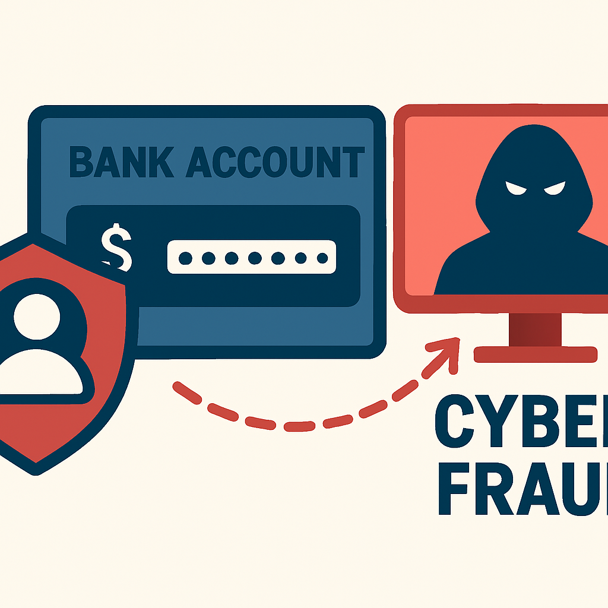
I have suppose problem bank fraud which is in the cyber fraud.

AI Tools you can use for Step 3-5:
ChatGPT/Perplexity AI: You can use these tools to compare your solutions and choose the most effective one
AI Tools you can use for the take-home task:
Canva AI/CoPilot AI/Meta AI: Use these mobile-based tools to generate images for the solution they want to design

Day 3: Prototype & Test
Step 6: Prototype – Building my first version
- What will my solution look like?
[Take inspiration from the image generated on Day 2 and describe the solution]
___________________The Cyber Safety Awareness App will have a simple, colorful interface with three main features:
1. Daily Safety Tips – Short advice on how to stay safe online.
2. Scam Alert Section – Latest fraud types and warning signs.
3. Interactive Quiz & Learning – Fun quizzes and badges to reward awareness.______________________________________________________________
- What AI tools will I need to build this?
[Prompt: “I am ideating a solution for <enter your problem in detail> I have designed a solution which includes <enter your solution description> What open-source, free AI tools that I can use to build this solution? The tools should be easily available and accessible on my mobile. Do not recommend tools which requires cost or subscription.
Ans:I am ideating a solution for cyber fraud detection and awareness.
I have designed a solution that includes an AI chatbot and analyzer to detect fraudulent messages, educate users about scams, and provide real-time alerts.
To build this, I will use open-source and free AI tools that are easily available on mobile.______________________________Ans:-____________________________
- What AI tools I finally selected to build this solution? [Eg: Claude AI, Grok AI, Chatling Ail
- ChatGPT – for conversation design and fraud detection content.
- Canva AI – to design posters and UI mock-ups.
- Figma AI – to create the app prototype.
•_Perplexity AI – to gather real-time data on new fraud types.____
•Chatling AI – to build chatbot logic and responses.__
__________________
________________________

__________________
<BUILD YOUR INNOVATION> <TEST YOUR INNOVATION>
Step 7: Test – Getting Feedback
- Who did I share my solution with? [You may share it with your trainer, peers or even AI]
Ans: _I shared my solution with my trainer and two peers from my project group._______________________________________________________________________
- What feedback did I receive?
👍 What works well:
The chatbot idea is simple and useful for all age groups.

B

Interface design is clear and easy to use.

Real-time fraud detection and safety tips are very helpful.

🔧 What needs improvement:
Add a reporting option directly to cyber crime portal.

Include regional language support.

Improve accuracy of fraud detection for local scams.

Take-home task
Record your solution and test feedback in voice notes. Upload your voice notes, images and your solution/model on GitHub
AI Tools you can use for Step 6-7:
ChatGPT/Perplexity AI/Claude AI/Canva AI/Chatling AI/Figma AI: You can use these tools to build solutions/models or mock-up dummy prototypes

Day 4: Showcase
Step 8: Presenting my Innovation
- Final Project Title:
__Cyber Fraud Detection and Awareness System_______________________________________________________________________
- Document key points of my presentation:
[Prompt with attachment/screenshot of your solution: “I am ideating a solution for <enter your problem in detail> I have selected a solution which includes <enter your solution description> I tested the solution with <enter details of who tested your solution> and they gave the following feedback <enter feedback given by the testers> Generate a 1-minute pitch document with following headings: project title, problem statement, my innovation, feedback I received from users, impact of my innovation. Add the attached image in the pitch document”]
I am ideating a solution for cyber fraud, a growing problem where individuals lose money or data due to online scams and phishing.
I have selected a solution which includes a web-based system that detects suspicious links, provides real-time alerts, and educates users about different types of cyber fraud through interactive modules.

I tested the solution with five classmates and one teacher. They found the awareness section very informative and said the fraud detection alert system was simple and effective to use.

Feedback received from testers:

The interface is user-friendly and easy to understand.

The alert messages are quick and helpful.

Suggestion: Add more examples of real-life fraud cases.

1-Minute Pitch Document (Key Points):

Project Title: Cyber Fraud Detection and Awareness System

Problem Statement: Increasing cases of online scams and lack of awareness among users.

My Innovation: A simple AI-based platform to detect fraudulent links and educate users on cyber safety.

Feedback Received: Testers appreciated the awareness modules and detection accuracy.

Impact: Helps reduce the risk of online scams and promotes safe internet habits.

<SHOWCASE YOUR INNOVATION TO YOUR PEERS>
Step 9: Reflections
- What did I enjoy the most during this project-based learning activity?
ANS:__I enjoyed creating the awareness section and designing the interface with Canva AI. Testing the tool with others and getting positive feedback._________________________________________________
- What was my biggest challenge during this project-based learning activity?
_Ans:_The biggest challenge was training the detection model and collecting real fraud link examples safely without exposing personal data.
_____________________________________________________________________

Take-home task
Upload your pitch document on GitHub
AI Tools you can use for Step 8:
Canva AI: You can use this to design your pitch document. Download your pitch document as a PDF file and upload on GitHub

